**Lab Assignment 12**

**Student Name: Chauhan Vandana Ramdayal**

**Student Id: AF0411629**

**Topic : List**

Q1.Write a Python program to sum all the items in a list. Code:

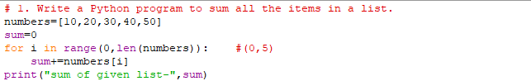

Output:



Q2Write a Python program to traverse a given list in reverse order, and print the elements with the original index.

Original list: ['red', 'green', 'white', 'black'] Traverse the said list in reverse order: black white green red.

Code:

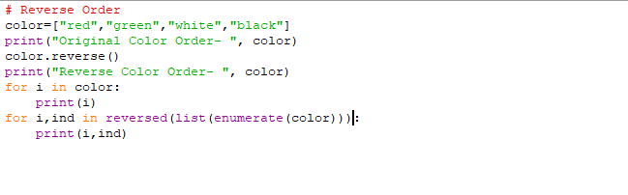

Output:

